Alli Richardson
Operations Manager, SIP Voluntary & Community Support Team, Community Resource
SIP Partners are:
Community Resource Qube SYA Energize
Citizens Advice Shropshire Hands Together Ludlow Shropshire Voluntary Sector Assembly Mayfair Mental Health Shropshire
Working collaboratively and in partnership to support Shropshire’s Communities & deliver services
Shropshire Infrastructure Partnership
Our aims are to:
- Improve the lives of people living and working in Shropshire
- Support and encourage community-led action and strong local governance
- Strengthen the long-term sustainability of local community life
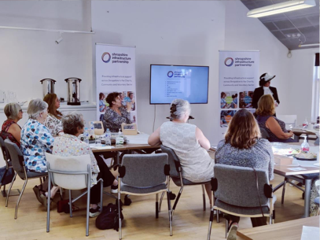
The SIP Voluntary & Community Support Team offers free advice, guidance and support to local charitable groups and organisations. Whether you are thinking of setting up a community group, a fairly new group or organisation, or have been established for many years, we can support you with the following:
Advice and Guidance for community groups and charitable organistions with regards to:
Governance support and legal structure advice Compliance and sustainability Policy creation and Policy Development Good Practice in Volunteer Recruitment and Management Support with charity commission registration
Roles & responsibilities of trustee and committee members. Annual Reporting

Training
We have a programme of commissioned and accredited training online and in person to support your group, organisation or volunteer needs to support community leadership and social action.
Grant and Funding Promotion
Grant and Funding advice support with finding funding opportunities Support & guidance with writing a funding application Access to small grant awards. Meeting funder reporting requirements
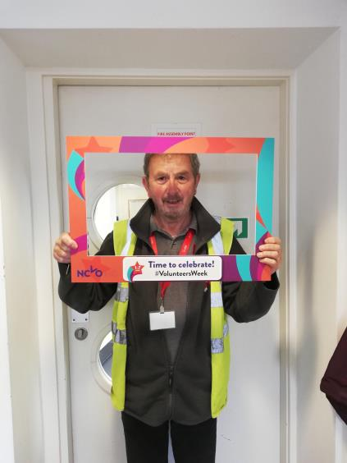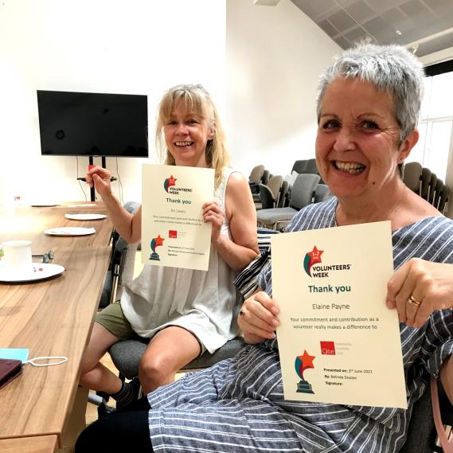
Volunteering in Shropshire
1682 registered charities in Shropshire 35,947,704 annual volunteer hours donated equates to £578mil Average of 59 days per year per organization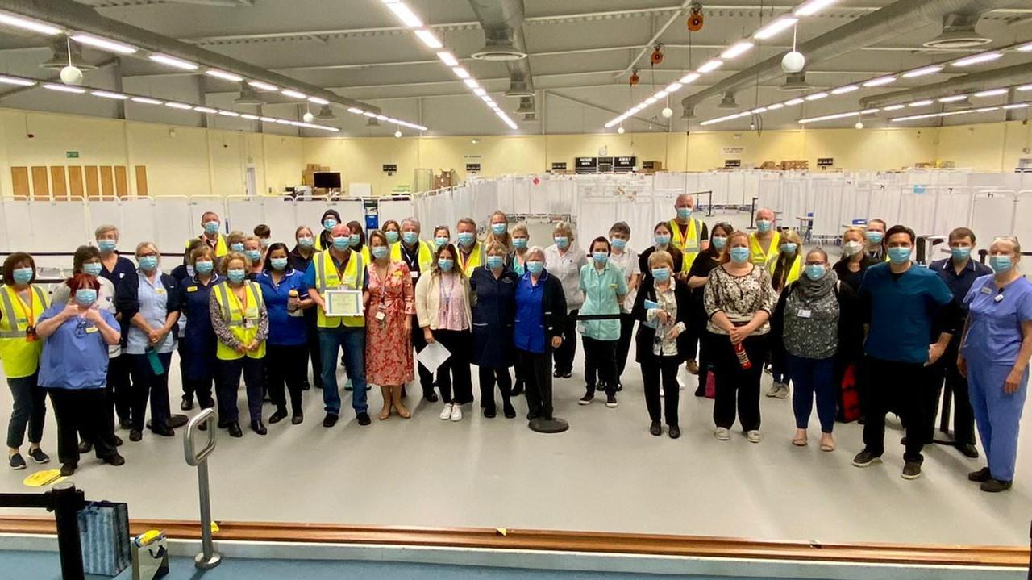
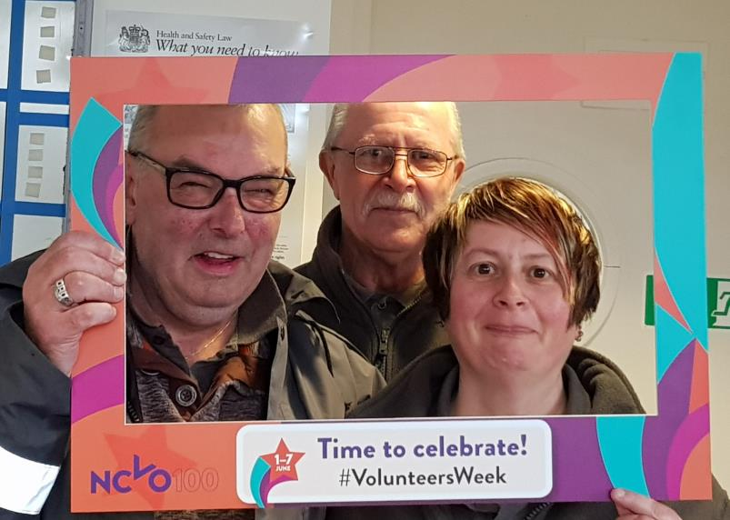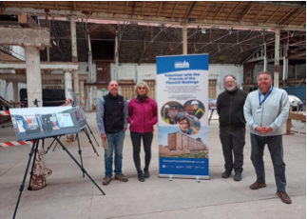
Volunteer Brokerage
We also provide free volunteer brokerage services placing local, trained volunteers into community groups and organisations, to facilitate positive volunteering experiences to achieve the most impact.
We aim to promote best practice in all areas of volunteer recruitment & management, ensuring choice and opportunity for people wishing to volunteer in their local communities.
Benefits of Volunteers and Volunteering
Volunteers
Satisfaction of doing something worthwhile The chance to use skills and experience for good The feeling of being part of something bigger Being appreciated and acknowledged for the contribution made Improved health and wellbeing Reduced social isolation and better support networks
Organisations
Involving volunteers improves variety & diversity within an organisation and brings new perspectives. Local volunteers bring the community into your organisation and allows local people to be a part of what’s being done
Volunteers enhance the experience for staff, other volunteers and the people The organisation serves.

Shropshire Infrastructure Partnership
SIP Volunteer and Infrastructure Team
1. One to one advice and guidance including mentoring
2. Volunteer brokerage
3. Infrastructure resources
4. Training workshops and information sessions
5. Collaborative working with Community Connectors & Social Prescribing
6. Funding & Grant Support

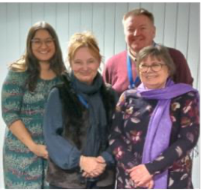

If you would any additional information, please email us: sipvcsteam@community-resource.org.uk

